**Software Engineering Department**

**Braude College of Engineering**

**EyeNet AI-Driven Early Eye Conditions Detection using Video Analysis**

**Project Code: 25-1-D-3**

**Capstone Project Phase A – 61998**

**Feb 2025**

**Gal Bitton**

**Ron Bendel**

**Git repository link:**

[GalBitton/EyeNet-Eye-Disease-Detection](https://github.com/GalBitton/EyeNet-Eye-Disease-Detection)

**Table of Contents**

*Abstract* 5

1. Introduction 5

2 Background and Related Work 6

2.1 Eye Conditions, Symptoms and their global impact 7

2.1.1 Eye Conditions and their global impact 7

2.1.2 Symptoms, Causes and Traditional Diagnostics 7

2.1.3 The Importance of Early Detection 9

2.2 Video Overview – Video & Image Processing 10

2.2.1 Video Architecture and Structure 10

2.2.2 Analyzing Videos for Diagnostic Precision 11

2.2.3 Challenges in Video-Based Diagnostics 11

2.3 Object Detection in General 12

2.4 Existing Solutions for Face and Eyes Region Detection 13

2.4.1 Classical Methods 13

2.4.2 Deep Learning-Based and Machine Learning-Based Solutions 14

2.4.3 Strength & Limitations 14

2.5 Existing Applications for Eye Condition Detection 15

2.5.1 CRADLE (ComputeR-Assisted Detector of LEukocoria) 15

2.5.2 AEYE Health 15

2.5.3 MD EyeCare 15

2.5.4 Comparison with Our Application & Model 16

2.6 Advances in Image Analysis and CNN 17

2.6.1 Advances in Image Analysis for Medical Diagnostics 17

2.6.2 Convolutional Neural Networks (CNNs) 17

3 Expected Achievements 19

3.1 Outcomes 19

3.2 Unique Features 20

3.2.1 Attention-Enhanced DenseNet121 Architecture 20

3.2.2 Video-Based Analysis 20

3.2.3 DLib for Detection 20

3.2.4 User-Friendly Interface 20

3.2.5 Cross-Platform Compatibility 20

3.3 Criteria for Success 20

4 Research/Engineering Process 21

4.1 Research – Eye Condition Detection 21

4.2 Research – Dataset 22

4.2.1 Data Collection Challenges 22

4.2.2 Data Augmentation 22

4.2.3 Preprocessing and Data Refinement 23

4.3 Research – Base Model Selection 23

4.3.1 Visual Geometry Group (VGG 16) 24

4.3.2 Residual Networks (ResNet50) 24

4.3.3 InceptionV3 24

4.3.4 DenseNet121 25

4.3.5 Model Performance Measures 25

4.3.6 Training Results 26

4.4 Research & Engineering – Enhance Selected Model 29

4.4.1 Attention Mechanism Overview 29

4.4.2 Hypotheses and Expected Improvements 30

4.5 Methodology and Development Process 30

5 Product 32

5.1 Backend Development 32

5.1.1 Tasks of Backend 32

5.1.2 Backend Technologies 35

5.2 Frontend Development 35

5.2.1 Tasks of Frontend 35

5.3 Requirements 36

5.3.1 FR Requirements 36

5.3.2 NFR Requirements 36

5.4 Model Structure 38

5.5 Architecture Overview 38

5.6 System Flow 39

5.7 System Use Case 40

5.8 System Activity Diagram 40

5.9 System User Interface 41

6 Verification and Evaluation 43

6.1 Evaluation 43

6.2 Verification 44

7 References 46

# *Abstract*

*The sense of sight is the sense that we as humans use in every activity of our daily lives. The eyes are a sensitive organ and are exposed to infections and bacteria, and as a result, there are several external eye diseases, including cataracts, conjunctivitis, and styes. These diseases significantly affect daily functioning and vision if not detected early. Despite technological advances, accessible and effective diagnostic tools remain limited, and diagnosis today is still time-consuming, can be an expensive process, and sometimes even requires specialized medical equipment.*

*This project presents* ***'EyeNet'****, an* ***end-to-end user-friendly*** *application designed to identify and classify external eye conditions with an emphasis on cataracts, conjunctivitis, and styes. Using advanced convolutional neural networks (CNNs), 'EyeNet' incorporates* ***DenseNet121*** *as its base model, enhanced with* ***attention mechanisms*** *to improve performance. The model was trained on a dataset of over 13,000 images in each class, with data augmentation techniques to improve robustness to changing conditions such as lighting changes and image noise. In our initial tests, we see promising accuracy of around* ***91% with DenseNet121****, and we speculate that further improvements in attention mechanisms are expected to increase performance.*

*‘EyeNet’ combines a FastAPI backend with a React-based frontend, providing a user-friendly and accessible interface for users to upload videos of their eyes and receive accurate and reliable diagnostic results. The project demonstrates the potential of advanced deep learning models combined with accessible, affordable and efficient technology, and we hope to bridge the gap that currently exists in the field of eye diagnosis and medical treatment.*

# Introduction

Worldwide, at least 2.2 billion people suffer from near or far vision impairment. In at least one billion of these, vision impairment could be prevented or is still untreated [1]. Cataracts, for example, are one of the leading causes of visual impairment and blindness worldwide [2].

With the global prevalence of eye diseases such as cataracts, retinitis pigmentosa, and conjunctivitis, there is an urgent need for accessible diagnostic tools. If left untreated, these diseases can lead to significant discomfort and vision loss. Cataracts alone account for more than 51% of global blindness, making them a leading cause of preventable vision loss [3]. Today, traditional diagnostic methods include in-person consultations with a specialist and the use of specialized eye equipment that is often inaccessible to people in peripheral areas and is often very expensive [4].

In this project, we wanted to try to address these challenges by providing a cost-effective, scalable and user-friendly solution for early detection of eye conditions to allow the end user to identify and treat the disease in time, thus facilitating the medical diagnosis process of the disease to some extent. Our system, EyeNet, is based on a deep personal story: First, we will share that one of the team members himself suffers from recurrent eye problems, and that our grandparents were diagnosed with cataracts at an early stage, and since we and our family live in a peripheral area, the diagnosis and treatment process was limited and expensive. The long queues for specialists prompted us to design an innovative solution. EyeNet leverages innovative artificial intelligence techniques to bridge the gap in accessibility to eye health, allowing people to proactively monitor their eye health using standard mobile cameras.

Deep learning has revolutionized the field of medical imaging by introducing powerful models capable of analyzing complex datasets [5]. Convolutional Neural Networks are particularly effective at extracting hierarchical features from visual data, making them a natural choice for us to diagnose eye conditions. Enhanced with attentional mechanisms, our CNN models should learn to focus on critical image regions, improving their ability to detect subtle symptoms related to cataracts, styes, and conjunctivitis [6].

EyeNet processes video content by identifying facial regions, isolating eyes, and analyzing them frame by frame. With this approach, we essentially ensure that diagnostic accuracy is based on a sophisticated average of all frames in the video, allowing us to be accurate even under varying video conditions. With the help of Convolutional Neural Networks and a user-friendly interface, we aim to contribute to the advancement of ophthalmology. This approach has the potential to prevent many people from suffering from eye diseases and enable effective and timely treatment.

# 2 Background and Related Work

In this chapter, we are going to discuss the global impact of external eye conditions, their symptoms, and traditional diagnostic methods. In addition, we will explore advancements in video analysis, object detection, and CNN technologies, laying the groundwork for our proposed AI-driven diagnostic solution.

## Eye Conditions, Symptoms and their global impact

For us to effectively address the problem and develop a robust, stable, and effective solution, it is essential to first understand the various eye conditions, their global impact on public health, and the current diagnostic approaches used to identify them.

### Eye Conditions and their global impact

As previously noted, external eye diseases, such as cataracts, styes, and conjunctivitis, are significant contributors to global visual impairment and discomfort. According to the World Health Organization (WHO), cataracts alone account for 51% of blindness worldwide, particularly in low- and middle-income countries where access to eye care remains a challenge [3]. Styes, although not a cause of blindness, are localized infections of the eyelid that cause pain and swelling, greatly impact daily activities, and create a strong sense of discomfort. Styes are also contagious. Similarly, conjunctivitis, commonly known as pink eye, causes irritation, redness, and discharge, which can spread rapidly through communities if left untreated [7].

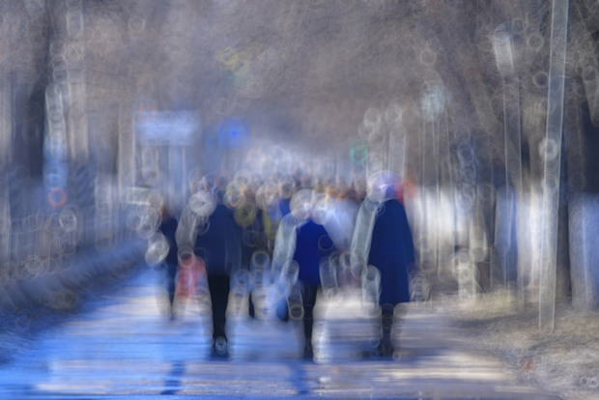

Figure 1. Vision with Untreated Cataracts   
This figure illustrates the blurred and distorted vision caused by untreated cataracts, highlighting the impact of lens clouding on visual clarity and the importance of timely treatment to prevent vision loss.

### 2.1.2 Symptoms, Causes and Traditional Diagnostics

Each of these conditions presents unique symptoms and Causes:

#### Cataracts

A cataract is a clouding of the eye's natural lens, leading to blurred or impaired vision.  
Primarily associated with aging, cataracts can also result from factors such as diabetes, prolonged exposure to ultraviolet radiation, smoking, and certain medications like corticosteroids.   
Cataracts can cause cloudiness and blurriness in vision that may gradually spread, faded or yellow-tinged colors, progressive difficulty seeing at night, increased sensitivity to light, halos around lights, double vision or ghost-like images, and a gradual decline in visual clarity, which can lead to blindness if left untreated. [8]

Figure 2 Example of eye with cataract

#### Styes

A stye is a painful, red bump near the edge of the eyelid, caused by an acute bacterial infection of an eyelash follicle or oil gland.

Styes are typically caused by Staphylococcus bacteria infecting the oil glands or hair follicles of the eyelid. Poor eyelid hygiene, touching the eyes with unclean hands, and using contaminated eye makeup can increase the risk. [9]

Symptoms include a red, swollen, and painful lump on the eyelid, tenderness, a feeling of something in the eye, and sometimes tearing or crusting around the eyelid.

Figure 3 Example of eye with stye

#### Conjunctivitis

Conjunctivitis, commonly known as pink eye, is the inflammation or infection of the conjunctiva—the transparent membrane lining the eyelid and covering the white part of the eyeball—resulting in redness and swelling.

It can be caused by viruses, bacteria, allergens (such as pollen or pet dander), irritants like smoke or chlorine in swimming pools, or contact lens use.  
Symptoms include redness in the white of the eye or inner eyelid, increased tearing, thick yellow discharge that crusts over the eyelashes (especially after sleep) in bacterial conjunctivitis, itchy eyes in allergic conjunctivitis, and a burning sensation. [10]

Figure 4 Example of eye with conjunctivitis

#### Current Diagnostics

Current diagnostic methods include **external examinations** using slit-lamp bio-microscopy and direct observation of symptoms. For cataracts, specialists rely on techniques such as visual acuity tests and ophthalmoscopy to assess the degree of lens opacity. Conjunctivitis is often diagnosed clinically based on the patient’s symptoms and history, while sty**es** are visible to the naked eye. However, traditional diagnostic methods require a doctor’s appointment and the presence of specialized equipment, which limits their reach in peripheral areas [11]. Internal eye conditions such as diabetic retinopathy and glaucoma are benefiting from advances in fundus photography and retinal imaging.

Unfortunately, external eye conditions remain underserved in terms of diagnostic technological tools, especially in non-clinical settings. We aim to address this gap with innovative diagnostic techniques that are portable, cost-effective, and easy to deploy.

### The Importance of Early Detection

Early detection of external eye conditions is essential to prevent long-term complications. For example, untreated cataracts can progress to complete blindness as seen in Figure 1, while late diagnosis of conjunctivitis can lead to serious infections and corneal scarring. Early detection allows for timely medical intervention, reducing the burden on healthcare systems and improving the quality of life of patients [3].

Artificial intelligence-driven mobile solutions that use videos or photos taken with standard mobile devices can make eye health diagnosis efficient and easy to use, allowing people to monitor their eye health without needing immediate access to specialists and check their eye health anytime, anywhere.

## Video Overview – Video & Image Processing

A central part of the solution we offer involves analysis and processing performed on video. In this section, we will review the structure of video, video analysis for accurate diagnosis, and the challenges we face in video analysis-based diagnostics.

### Video Architecture and Structure

Videos, unlike static images, consist of continuous sequences of frames that capture temporal and spatial information. A video is essentially a structured collection of still images (frames) displayed in rapid succession, typically at 24 to 60 frames per second (fps), creating the illusion of motion. Each video frame is a static snapshot, and collectively, they contain a wealth of visual data that can be analyzed for diagnostic purposes [12].

The architecture of video data includes several critical components:

**Frames:** A video is composed of individual images called frames. When these frames are displayed in rapid succession, they create the illusion of motion. Each frame captures a moment in time, and collectively, they form the visual content of the video.

**Frame Rate**: This refers to the number of frames displayed per second (fps). Common frame rates include 24 fps (standard for films), 30 fps (common for television), and 60 fps (used for high-definition video and sports). A higher frame rate results in smoother motion representation, enhancing the viewing experience.

**Resolution**: Resolution refers to the number of pixels in each frame of a video, determining its clarity and detail. For instance, a 1080p resolution means the frame has 1,920 pixels in width and 1,080 pixels in height, totalling approximately 2 million pixels. Higher resolutions, like 4K (3,840x2,160 pixels), offer even more detail but require more storage space and processing power.

**Temporal Continuity**: This aspect involves the motion patterns and changes that occur across sequential frames. Temporal continuity ensures that movements appear fluid and natural, which is crucial for maintaining the realism of the video.

**Spatial Information**: Spatial information refers to the details captured within individual frames, including colors, shapes, and regions of interest. This information is vital for tasks such as object recognition and scene understanding in image processing applications.

Figure 5 Schematic representation of a video structure

### Analyzing Videos for Diagnostic Precision

Analyzing videos for diagnostics requires extracting individual frames to allow static image processing while retaining temporal relationships. This process, called **frame extraction**, ensures that videos are broken into manageable components for precise analysis. By combining spatial analysis (frame-by-frame) with temporal consistency, systems can detect patterns that remain unnoticed in single images [13].

By treating videos as a series of frames, systems like EyeNet can focus on static image processing techniques while leveraging temporal consistency for robust diagnosis. This hybrid approach ensures that challenges such as motion blur and lighting inconsistencies can be effectively mitigated. Moreover, this method allows the integration of advanced machine learning models that can analyze spatial and temporal data simultaneously. Such systems are particularly valuable in medical imaging, where early detection of abnormalities can significantly improve patient outcomes. Frame-based analysis also offers scalability, as it can process large amounts of video data efficiently. Ultimately, a combination of these techniques improves the accuracy and reliability of video-based diagnostic tools.

### Challenges in Video-Based Diagnostics

While video-based diagnostics offer promising opportunities for automated analysis, they present several technical challenges that must be addressed to ensure reliability and accuracy [14]:

**Variation in lighting:** Variations in lighting between frames can blur visual features, especially in real-world environments.

**Motion blur:** User or camera movement can introduce blur, resulting in the loss of critical image details.

**Irrelevant frames:** Videos often contain unnecessary frames, such as frames with incomplete facial areas or closed eyes.

**Camera angles:** changes in head tilt and distance from the camera affect the consistency of extracted visual features.

To overcome these challenges, video data is usually split into frames for analysis. Pre-processing techniques such as frame stabilization, noise reduction and brightness normalization are applied to improve the quality of the frames and ensure easier and more efficient image processing for a learning machine.

Frame-based analysis ensures that critical information is stored and processed efficiently. In EyeNet, this step lays the foundation for accurately locating face and eye regions, ensuring that only high-quality and relevant frames are passed to the diagnostic model to produce an accurate and reliable diagnosis.

|  |  |  |
| --- | --- | --- |
| Challenge | Description | Solution/Technique |
| |  | | --- | | **Lighting variations** | | Uneven illumination affects visibility of eye features | |  | | --- | | Brightness normalization |  |  | | --- | |  | |
| |  | | --- | | **Motion blur** | | |  | | --- | | Blurred frames due to head or camera movement |  |  | | --- | |  | | |  | | --- | | Frame stabilization and sharpness enhancement |  |  | | --- | |  | |
| |  | | --- | | **Dynamic camera angles** |  |  | | --- | |  | | |  | | --- | | Changes in orientation or positioning of the face |  |  | | --- | |  | | |  | | --- | | Alignment through face and eye detection models |  |  | | --- | |  | |
| |  | | --- | | **Occlusions and irrelevant frames** |  |  | | --- | |  | | |  | | --- | | Frames where the eye region is obstructed |  |  | | --- | |  | | |  | | --- | | Frame filtering using bounding box validation |  |  | | --- | |  | |
| |  | | --- | | **Noise in video frames** |  |  | | --- | |  | | |  | | --- | | Pixel noise reduces clarity of subtle eye features |  |  | | --- | |  | | Noise reduction filters |

Table 1 Challenges in video-based diagnostics and the technique to solve them

## Object Detection in General

Object recognition is a basic task in computer vision that identifies and locates objects within images or videos. Unlike basic image classification, where the entire image is labelled in one class, object recognition recognizes multiple objects and knows how to differentiate between them and also identifies their location using bounding boxes. This technology serves as the basis for more advanced applications, such as facial recognition, autonomous driving and medical diagnosis.

In medical diagnosis, object detection enables the localization of anatomical structures, such as lesions, tumors or specific areas such as the eyes. By narrowing the focus to areas of interest, object detection improves the accuracy and efficiency of diagnostic tools. For example, in ophthalmology, face recognition and isolation of the eye region is critical for evaluating external eye conditions such as cataracts or conjunctivitis [15,16]. The ability to identify and isolate specific regions, such as the face and eyes, within video frames ensures that diagnostic systems can process only the most relevant information. This focus minimizes computational complexity and improves the accuracy of subsequent analyzes.

With the help of transferring the desired information, you get more accurate and reliable results.

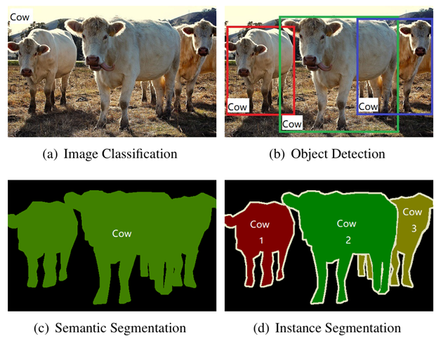

Figure 6 Comparison of different visual recognition tasks in computer vision. [16]

## Existing Solutions for Face and Eyes Region Detection

Face and eye detection techniques have evolved significantly, offering powerful solutions for isolating landmarks and eye regions within video frames. These solutions are the fundamental component of medical systems that deal with external detection and eye diagnosis and enable accurate extraction of areas of interest for further analysis.

### Classical Methods

Early methods relied on hand-crafted features and rule-based approaches:

**Viola-Jones Algorithm**: A pioneering real-time face detection technique using Haar-like features and cascading classifiers. Though efficient, it struggles with occlusions and variations in camera angles [17].

**Haar Cascades**: An OpenCV-based method optimized for lightweight face detection. While efficient, these methods lack robustness in dynamic environments and are limited by their inability to handle occlusions and varying camera angles [18].

### Deep Learning-Based and Machine Learning-Based Solutions

Modern solutions leverage deep learning and convolutional neural networks to achieve higher accuracy and flexibility:

**MTCNN (Multi-task Cascaded Convolutional Networks)**: Combines face detection with facial landmark localization, ensuring precise detection of the eye regions. It balances accuracy and multi-task capabilities but can be slower for large datasets or high-resolution inputs [19].

**DLib Facial Landmark Detection**: Utilizes a hybrid approach combining HOG (Histogram of Oriented Gradients) for feature extraction and SVM (Support Vector Machines) for classification. Detection is further refined using the *shape_predictor_68_face_landmarks.dat*, which identifies 68 facial landmarks, including the eyes. This approach effectively integrates classical methods, such as Haar cascades (*haarcascade_frontalface_default.xml* and *haarcascade_eye.xml*), with advanced landmark prediction for precise facial feature localization, even under challenging conditions [20].

**YOLO (You Only Look Once)**: A real-time object detection model that efficiently detects faces and eyes within video frames [21].

### Strength & Limitations

|  |  |  |
| --- | --- | --- |
| Algorithm | Strengths | Limitations |
| Viola-Jones | Fast, lightweight | Low accuracy in dynamic settings |
| MTCNN | High accuracy, multi-task learning | Slower processing on large inputs |
| YOLO | Real-time performance | Requires high GPU capabilities |
| OpenCV | Optimized for lightweight tasks | Limited robustness |
| DLib | Precise landmark detection | Computationally intensive |

Table 2 Strengths and limitations for each algorithm/model

## Existing Applications for Eye Condition Detection

In the domain of AI-driven solutions for diagnosing eye conditions, several applications have been developed to detect specific eye diseases through image analysis. We will cover some notable examples.

### CRADLE (ComputeR-Assisted Detector of LEukocoria)

CRADLE, also known as the White Eye Detector, is a mobile application designed to detect leukocoria—a white pupil reflex often indicative of retinoblastoma or cataracts. CRADLE analyzes casual photographs using machine learning techniques to identify leukocoria, demonstrating high accuracy in early detection, often months before a clinical diagnosis. However, CRADLE is limited to detecting leukocoria and does not address other external eye diseases like styes or conjunctivitis. [22]



Figure 7 Logo of CRADLE

### AEYE Health

AEYE Health is an AI-powered platform that uses deep learning algorithms to detect diabetic retinopathy and other retinal conditions from fundus images. Designed for use in primary care settings, it enables early diagnosis and treatment of diabetic eye diseases. While highly effective for internal eye conditions, AEYE Health does not extend to external eye diseases like cataracts, styes, or conjunctivitis. [23]



Figure 8 Logo of AEYE Health

### MD EyeCare

MD EyeCare is a mobile-based application aimed at detecting a variety of eye conditions using deep learning algorithms. The app allows users to upload images of their eyes for analysis and provides preliminary diagnostic results for conditions like cataracts and dry eye syndrome. While it supports external eye condition detection, its focus is primarily on static image inputs, limiting its adaptability for video-based workflows. [24]



Figure 9 Logo of MD EyeCare

### Comparison with Our Application & Model

|  |  |  |  |  |
| --- | --- | --- | --- | --- |
| Feature | CRADLE | AEYE Health | MD EyeCare | Our Solution (EyeNet) |
| Face Detection | None | Retinal imaging only | Static image detection | Automated face & eye detection |
| Eye Condition Detection | Leukocoria only | Diabetic retinopathy | Cataracts, Dry Eyes | Cataracts, Styes, Conjunctivitis |
| Input Type | Casual photos | Retinal images | Static images | Video & Image inputs |
| User-Friendly Interface | Yes | Yes | Yes | Yes |
| Cost | Free | Paid | Varies | Free |
| Scalability | Low | Moderate | Moderate | High |

Table 3 Comparison between existing applications with our project

By analyzing the table above, it becomes evident that while existing solutions like CRADLE, AEYE Health, and MD EyeCare excel in specific areas, they lack versatility when diagnosing multiple external eye conditions using dynamic video inputs. EyeNet addresses these limitations by processing video data, automatically identifying face and eye regions using advanced object recognition models and leveraging improved CNNs for comprehensive analysis.

EyeNet's video-processing capabilities and automated pipeline provide a robust, accessible, and economical solution, ensuring accurate detection of multiple external eye conditions in real-world scenarios. Unlike other solutions, it is designed to handle dynamic inputs seamlessly, making it more adaptable and user-friendly.

## Advances in Image Analysis and CNN

Our solution leverages existing image processing techniques and builds on the proven strengths of CNNs in medical diagnostics to enhance accuracy and reliability.

### Advances in Image Analysis for Medical Diagnostics

Image analysis brought about a profound change in medical diagnosis, enabling the automatic extraction of significant insights from medical images. Historically, medical imaging has relied on manual interpretation of X-rays, MRIs, and microscopy images. Although these traditional methods have been effective, their diagnosis is time-consuming and depends on expert judgment. Modern computer vision techniques, on the other hand, have automatic image analysis, leading to improved accuracy, reproducibility and grading in diagnosis [5,25].

In ophthalmology, image analysis has been widely applied to detect internal eye diseases, such as diabetic retinopathy and glaucoma. Technologies such as fundus photography and optical coherence tomography (OCT) have enabled high-resolution imaging of the retina, helping to detect early disease progression. However, external eye diagnostics, which include conditions such as cataracts, conjunctivitis and styes remain less studied despite their prevalence and impact.

Major advances in image analysis for medical diagnosis include:

**Segmentation:** Decomposing an image into regions of interest to isolate anatomical structures (eg pupil, sclera, eyelid or iris).

**Feature extraction:** identifying disease markers such as changes in texture, color or opacity.

**Classification:** assigning images to categories (eg, diseased vs. healthy) based on extracted features.

These techniques provide the basis for systems such as EyeNet, which focus on detecting external eye states from standard video inputs. By combining accurate feature extraction with robust classification, modern image analysis ensures early detection of subtle abnormalities that the expert may not notice with his analysis and diagnosis.

### Convolutional Neural Networks (CNNs)

**Convolutional Neural Networks** are the cornerstone of modern medical image analysis, excelling in tasks such as feature extraction, object localization, and image classification. Unlike traditional machine learning methods, CNNs automatically learn **hierarchical features** from visual data, making them ideal for detecting both high-level patterns and subtle variations within medical images [26].



#### Overturning Layers

Convolutional layers apply filters (kernels) to the input image to extract spatial features such as edges, textures, and patterns. Early layers focus on simple features such as lines and corners, while deep layers recognize complex patterns such as shapes and areas.

The convolution operation preserves the spatial relationship between pixels by learning image features. Multiple filters are used in each layer to detect different features, which enriches the understanding of image finesse. The output of these layers, called feature maps, serve as input to subsequent layers, passing on the extracted spatial information.

#### Pooling Layers

Pooling layers perform operations that reduce the spatial dimensions of feature maps, preserving critical information while improving computational efficiency. Common pooling techniques include Maximum Pooling, which selects the maximum value within a certain area of ​​the image whose size is determined in advance, and Average Pooling, which calculates the average. These layers contribute to reducing overfitting and improving model performance.

#### Fully Connected Layers

Fully connected layers connect the extracted features to the final output predictions. They map the learned patterns to specific classes, enabling tasks such as classification. For example, in medical imaging, a CNN might classify an image as "healthy eye" or "cataract" based on the features extracted by previous layers.

#### Activation Functions

Activation functions introduce non-linearities to the network, enabling CNNs to learn complex relationships within the data. Common activation functions include ReLU (Rectified Linear Unit), which helps address the vanishing gradient problem, and Sigmoid or Softmax for final output probabilities. These functions ensure that the network can model diverse patterns effectively.

ReLU, as one of the most widely used activation functions, introduces sparsity by setting all negative values ​​to zero, improving computational efficiency and convergence speed.

Sigmoid activation squashes outputs between 0 and 1, making it suitable for binary classification tasks, while Softmax normalizes outputs into probabilities across multiple classes.

Without activation functions, the CNN would behave as a linear model, severely limiting its ability to model complex data patterns.

To summarize in EyeNet, the CNN framework underlies the diagnostic model, allowing it to analyze eye regions extracted from video frames. By learning features such as opacity (for cataracts), swelling (for cataracts) or redness (for conjunctivitis), the CNN processes each frame to make accurate predictions. The results from all frames are then aggregated to provide a final and reliable diagnosis.

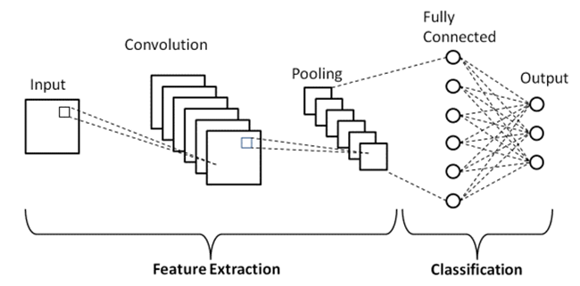

Figure 10 Basic architecture of CNN

# Expected Achievements

## Outcomes

In our project, we aim to develop a reliable, efficient and high-quality system that will provide accurate results for identifying eye diseases such as cataracts, barley and conjunctivitis. Our goal is to use advanced deep learning techniques such as a model called DenseNet121 as the basis for our model, on which we will add an attention mechanism that will focus and direct the learning process of our model to the relevant areas in the images it will decode.

In this way, we will be able to provide reliable diagnostic insights by decoding video captured on mobile devices that is divided into frames that are transferred to the EyeNet model to create a reliable and accurate diagnosis.

The combination of an application that is designed to be user-friendly, easy to use and available to the public together with our EyeNet model and the system's frame-by-frame analysis ensures that each detected eye is classified independently, allowing for a detailed and comprehensive diagnosis. This approach will allow our system to excel in challenging conditions, including changing lighting, angles, or partial visibility in some frames of the video.

## Unique Features

### Attention-Enhanced DenseNet121 Architecture

The integration of spatial and channel attention layers into DenseNet121 enhances the model’s focus on disease-relevant regions while filtering out irrelevant background elements. This improves accuracy and robustness, especially under challenging conditions like varying lighting or partial occlusion.

### Video-Based Analysis

Our system processes videos captured from mobile and computer cameras, analyzing frames individually to provide detailed insights for each detected eye. This frame-by-frame approach ensures comprehensive diagnostics for dynamic and real-world scenarios.

### DLib for Detection

DLib is used for precise face and eye region detection, enabling robust localization even in videos with head movement or variable lighting. Its pre-trained models ensure reliable detection and efficient preprocessing.

### User-Friendly Interface

A web-based interface allows users to upload videos, view results, and interpret outputs effortlessly. The interface is designed for accessibility, providing statistics in numerical form and diagnostics and recommendations in verbal form for easy understanding.

### Cross-Platform Compatibility

The application is accessible on both desktop and mobile devices, supporting various browsers and video formats. This ensures widespread usability and convenience for diverse users.

## Criteria for Success

**High Accuracy in Detection:** The system should achieve a classification accuracy of 95% or higher for detecting external eye conditions, including cataracts, styes, conjunctivitis, and healthy eyes.

**Efficient Video Processing:** Videos of up to 30 seconds should be processed within 15 seconds, ensuring timely results for users.

**Robust Eye and Face Detection:** DLib-based detection must handle challenging conditions, such as head movements, partial occlusions, and varying lighting, with a high success rate.

**User-Friendly Interface:** The web-based interface must be intuitive and easy to navigate, enabling users to upload videos and interpret results without technical expertise.

**Cross-Platform Compatibility:** The application should function seamlessly on both desktop and mobile devices, supporting popular browsers and video formats.

**Transparent Reporting:** The system should provide clear and detailed outputs, including classification confidence scores and visual attention maps, ensuring users can trust and understand the results.

**Stable Performance:** The application should maintain reliability, with minimal crashes or errors, ensuring smooth operation even under moderate loads.

# Research/Engineering Process

The research and engineering phase of our project has been divided into two primary semesters: the first dedicated to theoretical exploration, research, and designing the project's framework, and the second focusing on the actual development and implementation of the system. This phased approach allows us to build a solid foundation before transitioning into practical execution.

## Research – Eye Condition Detection

Our research began by exploring the challenges and opportunities in developing a system to detect external eye conditions such as cataracts, styes, and conjunctivitis. This initial phase focused on gathering foundational knowledge and identifying potential solutions, driven by the following critical questions:

* What are the solutions currently on the market that solve the problem? What do they specialize in? How can they be improved?
* What datasets are available for external eye images, and what are the challenges in collecting, refining, and preparing such data for deep learning and machine learning tasks?
* Which pre-trained neural network models are most suitable for classifying external eye conditions, and what criteria should guide the selection process?
* How can existing deep learning models be enhanced to improve accuracy, robustness, and generalization for video data analysis?
* What practical considerations should be addressed when processing video data from mobile and computer cameras, including variations in resolution, lighting, and noise?

By addressing these questions, we aimed to build a strong foundation for developing a scalable and reliable system capable of delivering accurate predictions while being user-friendly and adaptable to real-world scenarios. This research phase also helped us identify potential constraints and challenges, which shaped our subsequent approach.

## Research – Dataset

One of the main key components to the success of a machine learning model lies in the quality and quantity of the data used for training. In our project, finding a large, high-quality dataset was a challenging task.

### Data Collection Challenges

The main obstacle we faced when searching for the dataset was finding external eye images suitable for identifying conditions such as cataracts, styes and conjunctivitis. There are large amounts of datasets related to eye diseases and infections all over the internet but almost all of them often focus on internal eye images taken by specialized medical equipment. In our project, our dataset had to consist of external eye images – those taken using mobile phones or front-facing cameras.

To overcome this obstacle, we searched a wide range of websites, downloaded several different datasets that could serve our purpose, and merged them into a single dataset. The sources that provided us with the widest variety of external eye images were Kaggle and Roboflow Universe [27,28]. Despite an extensive search across the Internet, the volume of usable data was smaller than expected. The initial dataset contained an insufficient amount of external eye images, so we had to find a solution to the problem.

### Data Augmentation

As we noted that we were able to collect a relatively small dataset, we used data augmentation techniques to artificially enlarge it and improve the generalizability of the model [29]. These techniques included:

Rotation**:** Generating new images by rotating the original ones to simulate different viewing angles.

Flipping**:** Horizontally flipping images to increase variability.

Brightness and Contrast Adjustments: Altering brightness and contrast to simulate different lighting conditions.

Scaling and Cropping: Creating variations in image size and focus to improve robustness.

After a challenging process of collecting a large and high-quality dataset, the final dataset consisted of approximately 13,000 images per class, covering four categories:

**Healthy Eyes, Eyes with Cataracts**, **Eyes with Styes**, **Eyes with Conjunctivitis**

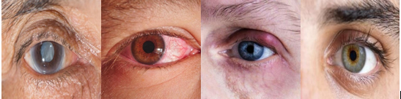

Figure 11 Visualization of sample dataset from left to right: Cataract eyes, Conjunctivitis eyes, Stye eyes and healthy eyes

Through this balanced distribution, we can allow the model to learn equally from each category, and try to reduce the risk of class bias during training as much as possible

### Preprocessing and Data Refinement

In order to move on to the next step and start training the models, we conducted a preprocessing steps:

**Data Filtering:** We manually checked the dataset to remove images that were irrelevant, unclear, or incorrectly labelled. For example, blurry images or images that did not prominently show the eye were excluded.

**Cropping:** Some images were manually cropped to focus on the eye area, ensuring consistency in input dimensions. This step was critical to reduce noise and improve the model’s focus on relevant features.

An important point that we had to pay attention to in our project was the main problem that arises from images taken with mobile phones such as lighting variations, image noise, and obstructions. Using image processing techniques, we improved the quality of each image, thereby trying to reduce the factors that could confuse the model during the training process.

## Research – Base Model Selection

When we talk about deep learning models, we need high-quality hardware and enough computing power to train complex models.

In our project, we run the various models on our personal computers (AMD Ryzen 9 7950X, 64GB RAM, Nvidia GeForce RTX 4080 Super), these computers have limited computational power and although we have managed to improve the size of our dataset, it is still not enough for deep learning models. Therefore, we decided to try to test our learning goal using different neural networks that have already been trained on image classification and adapt them and their weights to our dataset.

There are several models available. Keras, for example, has nine pre-trained models for computer vision tasks, TL, forecasting, feature extraction, and fine-tuning. We chose to test our dataset on four pre-trained models: VGG16, ResNet50, Inception V3 and DenseNet-121.

### Visual Geometry Group (VGG 16)

VGG16 is a widely used convolutional neural network architecture known for its depth and uniform design. It consists of 16 layers, including 13 convolutional layers utilizing 3×3 filters, and 3 fully connected layers. The model accepts input images of size 224×224×3 and employs max-pooling layers to progressively reduce spatial dimensions. This architecture enables VGG16 to effectively capture intricate features, making it suitable for various image classification tasks. [30]

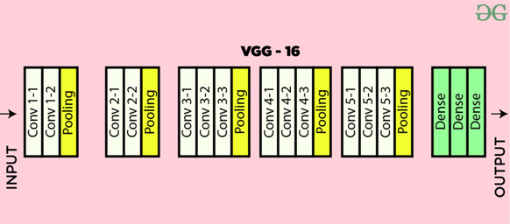

Figure 12 VGG16 Architecture

### Residual Networks (ResNet50)

ResNet50 is a deep convolutional neural network with 50 layers that introduced the concept of residual learning to address challenges in training very deep networks. It employs residual blocks with shortcut connections, enabling efficient gradient flow and improved accuracy in deep architectures. ResNet50 is widely used for image recognition tasks due to its ability to learn complex features effectively. [31]

Figure 13 ResNet50 Architecture

### InceptionV3

Inception V3 is a deep convolutional neural network designed for efficient and accurate image classification. It enhances the original Inception model with techniques like factorized convolutions, label smoothing, and auxiliary classifiers, optimizing both computational performance and feature extraction for complex image recognition tasks. [32]

Figure 14 InceptionV3 Architecture

### DenseNet121

DenseNet121, short for Dense Convolutional Network, is a 121-layer deep neural network that employs dense connectivity to improve feature propagation and reduce the number of trainable parameters. In this architecture, each layer is connected to every other layer, ensuring efficient reuse of features and mitigating the vanishing gradient problem. DenseNet121 consists of four dense blocks, each separated by transition layers that include convolution and pooling operations. With a total of approximately 8 million parameters. This model is particularly effective in extracting rich hierarchical features for tasks like image classification and object detection. [33]

Figure 15 DenseNet121 Architecture

### Model Performance Measures

Here are some of the measures for evaluating performance that was calculated. Using these criteria, we found the best classifier to detect eye diseases:

Accuracy

Measures the overall correctness of the model's predictions across all classes, **higher is better**. $Accuracy=\left(\frac{TP+TN}{TP+FN+FP+TN}\right)×100\%$.

True Positive Rate (TPR)

Evaluates the model's ability to correctly identify positive cases, **higher is better**. $True Positive Rate \left(TPR\right)=\left(\frac{TP}{TP+FN}\right)×100\%$

True Negative Rate (TNR)

Assesses how well the model identifies negative cases correctly, **higher is better**. $True Negative Rate \left(TNR\right)=\left(\frac{TN}{TN+FP}\right)×100\%$

False Positive Rate (FPR)

Indicates the proportion of negative cases incorrectly classified as positive, **lower is better $False Positive Rate \left(FPR\right)= \left(\frac{FP}{FP+TN}\right)×100\%$**

False Negative Rate (FNR)

Represents the proportion of positive cases missed by the model, **lower is better**. $False Negative Rate \left(FNR\right)=\left(\frac{FN}{FN+TP}\right)×100\%$

Precision

Reflects the model's ability to correctly predict positive cases without false alarms, **higher is better**. $Precision=\left(\frac{TP}{TP+FP}\right)×100\%$

F1 Score

Balances Precision and Recall to provide a single measure of model performance, **higher is better**. $F1 Score=\left(2×\frac{Precision×Recall}{Precision+Recall}\right)×100\%$

### Training Results

The dataset we used in this training process comprises 13,024 Images **per class,** diverged into 9,114 training images, 1,955 validation images and 1,955 test images for each class (Healthy, Cataract, Conjunctivitis, Stye). The experiment was conducted on our personal computer powered by an AMD Ryzen 9 7950X CPU with 64 GB of memory, and Nvidia GeForce RTX 4080 Super GPU. All input images for the VGG-16, ResNet50, Inception V3, and DenseNet121 models were scaled to 224×224 pixels.

The pre-trained weights of VGG-16, ResNet50, Inception V3, and DenseNet121, initialized with the ImageNet dataset, were fine-tuned for this experiment. The confusion matrices for the applied models, as shown in Table 1, report the **True Positives (TP)**, **False Negatives (FN)**, **False Positives (FP)**, and **True Negatives (TN)** for each of the four classes.

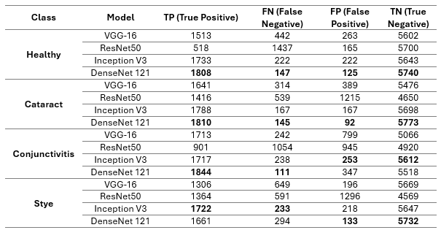

Table 4 Confusion Matrix for each class, testing on 4 Keras pre-trained models

As can be analyzed from the table, DenseNet121 outperforms all three other models in almost every parameter for every class.

Table 5 Performance evaluation matrices for all 4 Keras pre-trained models.

The performance metrics for the applied models, evaluate their ability to classify the four eye conditions (Healthy, Cataract, Conjunctivitis, Stye) using measures such as Accuracy, True Positive Rate (TPR), False Negative Rate (FNR), False Positive Rate (FPR), True Negative Rate (TNR), Precision, and F1 Score.

These metrics provide a detailed assessment of the models' strengths and weaknesses in correctly identifying positive cases, minimizing errors, and maintaining high precision across all classes. DenseNet121 demonstrated superior performance across most metrics, with the highest accuracy and F1 scores, highlighting its robustness in this application.

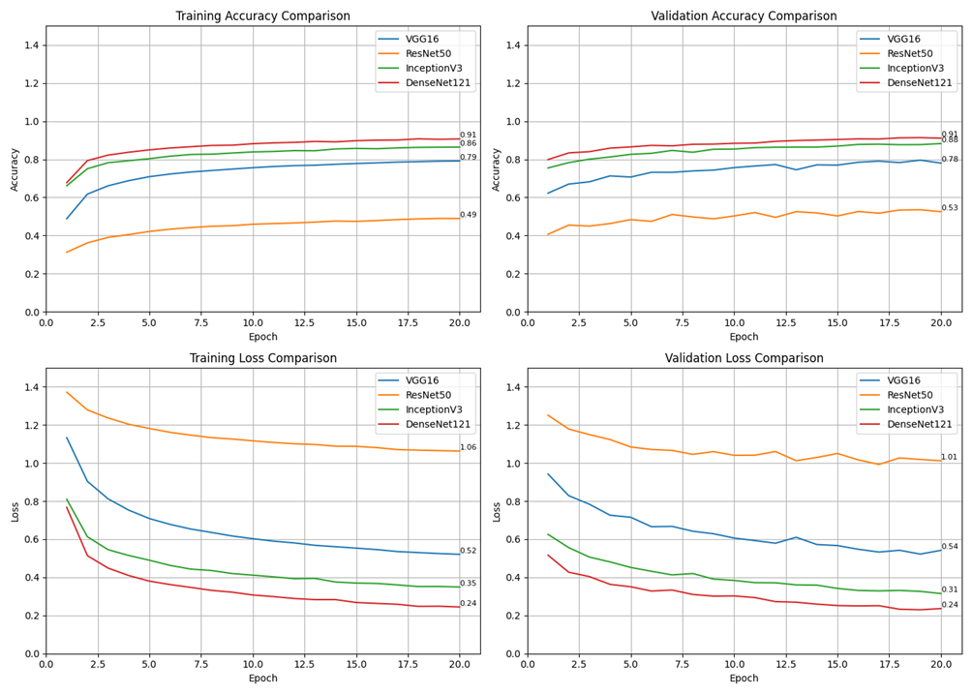

Figure 16 Visualization of the pre-trained models training and validation process

DenseNet121 demonstrated the best performance, achieving the highest training and validation accuracy (0.91 and 0.88, respectively) and the lowest loss values (0.24 for both). InceptionV3 followed with a strong validation accuracy of 0.86. VGG16 performed moderately, reaching a validation accuracy of 0.79, while ResNet50 showed the lowest performance, with a validation accuracy of 0.53 and higher loss throughout training. These results highlight the efficiency and reliability of DenseNet121 for our image classification task.

## Research & Engineering – Enhance Selected Model

After testing several pre-trained models (VGG16, ResNet50, InceptionV3, and DenseNet121), we identified DenseNet121 as the most suitable architecture for our solution due to its superior performance in classifying external eye images. These initial evaluations provided valuable insight into the type of Convolutional Neural Network best suited for this task. Building on this perspective, we aim to enhance DenseNet121 by integrating advanced attention mechanisms, including Spatial Attention, and Channel Attention.

These mechanisms are designed to improve the model's ability to focus on the most relevant features within the input data, refining its classification accuracy and robustness.

### Attention Mechanism Overview

Integrating attention mechanisms into the DenseNet121 architecture is hypothesized to improve its performance in classifying external eye images by enabling the model to focus on the most relevant features.



#### Attention Layers

These layers allow the neural network to dynamically prioritize specific regions or features within an input image, thereby improving feature localization and enabling the model to concentrate on critical areas indicative of eye conditions. [34]

#### Spatial Attention

This mechanism emphasizes **'where'** important features are located within the image. By generating an attention map that highlights crucial regions, the model can effectively focus on areas around the eyes that are most indicative of specific conditions. [35]

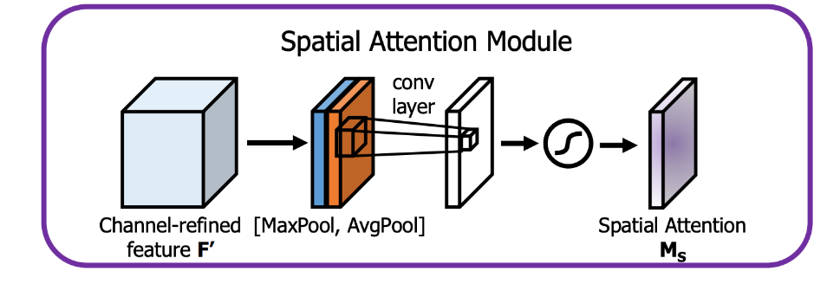

Figure 17 Architecture of Spatial attention layer

#### Channel Attention

This mechanism is focusing on **'what'** features are important, channel attention assigns different weights to various feature channels, each corresponding to specific visual attributes. This enables the model to prioritize channels capturing disease-relevant information, such as redness or swelling, thereby enhancing feature representation. [36]

Figure 18 Architecture of Channel attention layer

### Hypotheses and Expected Improvements

By integrating spatial attention, and channel attention mechanisms, we hypothesize the following improvements:

**Improved Generalization**: The model will better generalize across varying conditions, such as differences in lighting, camera quality, or noise, due to its ability to focus on relevant features dynamically.

**Enhanced Learning Efficiency**: By guiding DenseNet121 to prioritize key spatial regions and channels, the model will require fewer epochs to converge and achieve superior accuracy.

**Visual demonstration:** Attention mechanisms enable more interpretable outputs by visually demonstrating (Grad-CAM for example) which areas or features the model is focusing on during prediction.

We propose the integration of spatial attention and channel attention layers into the DenseNet121 architecture to refine its feature extraction capabilities. These enhancements aim to improve the model’s ability to focus on disease-relevant regions and features. For each eye disease the model should focus on different region of the eye. Cataract affects the pupil and iris, conjunctivitis affects the sclera while styes affects the eye lid. The modifications are expected to make DenseNet121 more resilient to noise, more efficient in its learning process, and more interpretable, making it an ideal candidate for the complex task of external eye disease classification.

## Methodology and Development Process

For our development process, we chose the Agile methodology, which allows for flexibility and adaptability as we progress through the project. By iterating in manageable stages, we can continuously refine our work while addressing challenges as they arise. The process is divided into the following key phases:

**Dataset Gathering and Preparation**

* Collecting datasets of external eye images from online sources such as Kaggle and Roboflow Universe.
* Conducting data preprocessing, including filtering irrelevant or low-quality images and cropping to focus on eye regions.
* Applying data augmentation techniques such as rotation, flipping, and contrast adjustments to expand and diversify the dataset.

**Model Implementation and Testing**

* Starting with pre-trained convolutional neural networks such as VGG16, ResNet50, InceptionV3, and DenseNet121.
* Testing and evaluating these models on static images to determine the most suitable architecture based on performance metrics like accuracy and F1 score.
* Enhancing the selected model by integrating attention mechanisms such as spatial and channel attention to improve its detection capabilities.
* Testing and evaluating the improved model on static images, pre-recorded videos, and real-world images of patients.
* Fine tune the improved model ‘EyeNet’.

**Frontend Development**

* Creating a user-friendly React-based interface for users to upload images and videos for analysis.
* Implementing timely and rapid feedback mechanisms to present results, including classifications and confidence scores.

**Basic Backend-Frontend Communication**

* Establishing the foundational API endpoints using FastAPI to handle communication between the backend and frontend.
* Allowing users to interact with the backend through the frontend to submit image and video files and receive results.

**Video Processing Pipeline**

* Developing a pipeline to process uploaded videos by splitting them into individual frames.
* Integrating DLib for facial and eye region detection across frames, ensuring consistent and accurate classification.
* Optimizing the pipeline for efficiency to handle varying video formats and resolutions.

**Model API Improvement and Refinement**

* Enhancing the backend API for better performance and scalability, ensuring accurate and timely predictions.
* Adding features to improve the robustness of the system in handling edge cases, such as poor lighting or partial occlusion.

**Refactoring and Optimization**

* Revisiting the codebase to improve modularity, readability, and maintainability.
* Addressing bottlenecks in performance and ensuring the system runs efficiently across different devices.

# Product

The product architecture is divided into two main components: the **backend** and the **frontend**, with clear communication between them. The backend handles all computational tasks, including video preprocessing, model inference, and result aggregation, while the frontend manages user interactions and displays the results in an user-friendly interface.

The architecture ensures modularity and scalability, making it easier to maintain and extend the system in future iterations. The core flow of the platform consists of:

**Backend**: Processes user uploads, decomposes videos into frames, detects and crops eye regions, performs model inference, and aggregates results.

**Frontend**: Allows users to upload files, displays predictions, and visualizes diagnostic results.

**Communication Layer**: RESTful APIs ensure smooth data exchange between the frontend and backend.

## Backend Development

The backend is the backbone of our platform, managing all computation-intensive tasks. It is designed to handle user uploads, preprocess video/image inputs, and perform inference using ‘EyeNet’ model. [37]

### Tasks of Backend

**Video Frame Extraction**: Instead of using FFmpeg, we chose Python’s cv2.VideoCapture (OpenCV) for video decomposing due to its simplicity and ease of use in extracting frames directly from uploaded videos. This method ensures precise frame capture with minimal overhead.

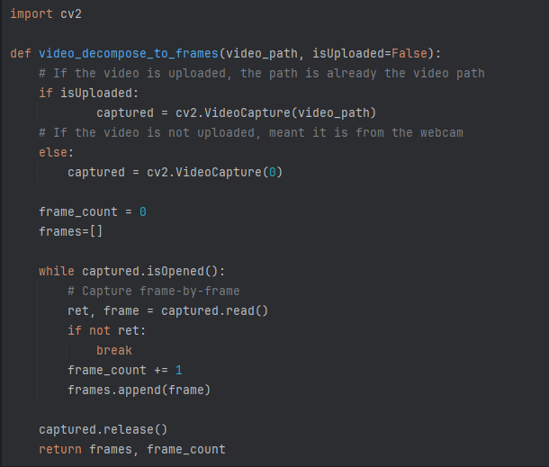

Figure 19 Code example for extracting frames from video using OpenCV

**Face and Eye Detection**: After extracting frames, the backend detects and crops eye regions using **DLib**. DLib was selected for its balance of accuracy and efficiency, making it ideal for real-time applications. A figure of comparison of the existing methods which we reviewed above.

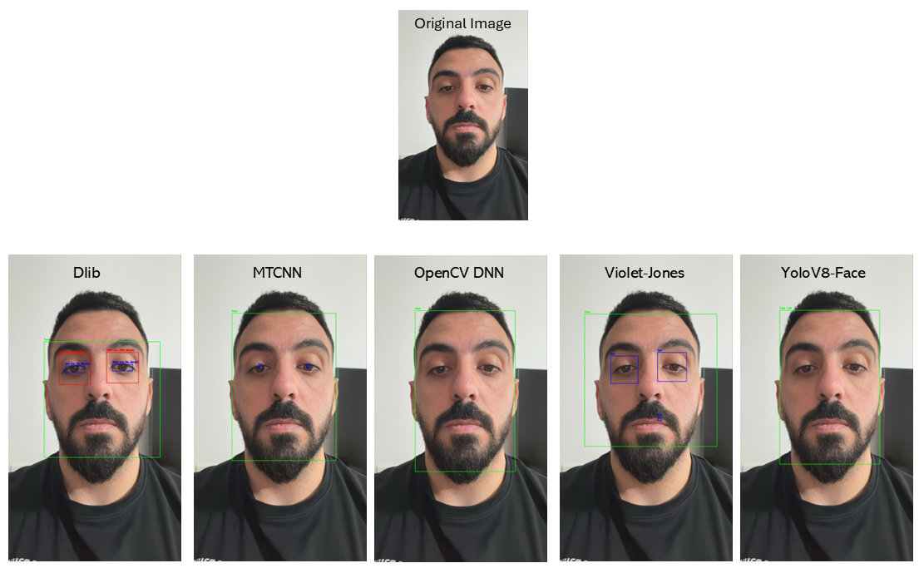

Figure 20 Comparing results of face and eye detection using 5 different models

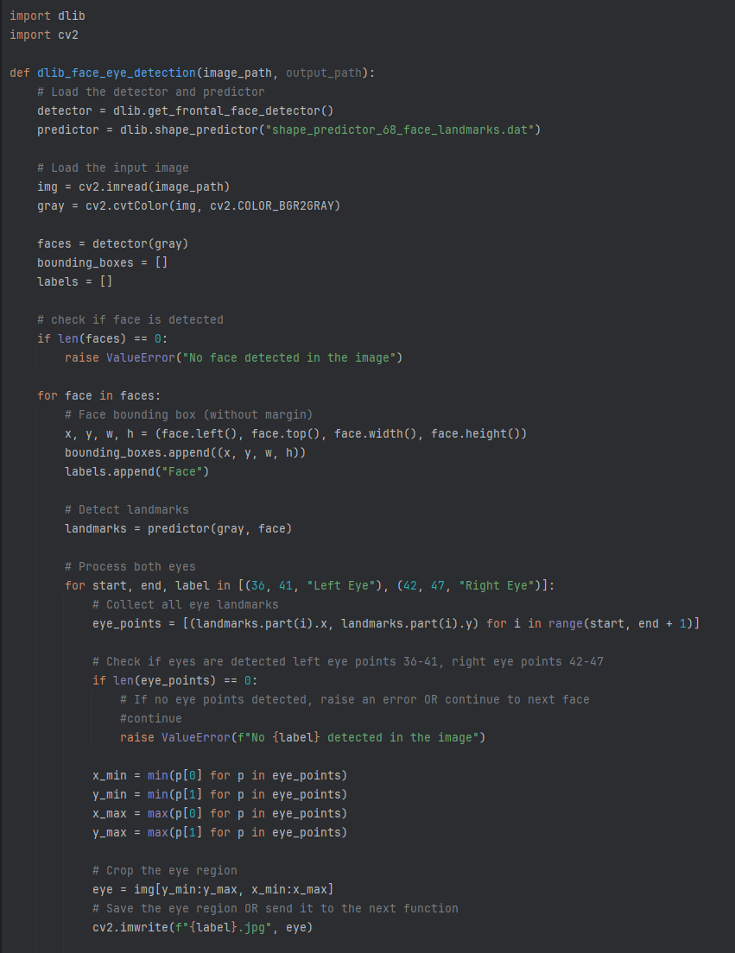

Figure 21 Code example of using DLib for face and eye detection

**Preprocessing**: Each frame is resized to 224x224, normalized, and prepared for model input to meet EyeNet’s requirements.

**Model Inference**: The pre-processed frames are passed through the DLib detection process, where the eye regions are cropped and sent to our ‘EyeNet’ model for classification into one of four categories: healthy, cataract, stye, or conjunctivitis.

**Result Aggregation**: Predictions for all frames in a video are aggregated into a comprehensive diagnostic summary, returned to the user via the frontend.

### Backend Technologies

**FastAPI**: Used for creating asynchronous RESTful APIs to manage backend tasks and interact with the frontend efficiently [38].

**Python Libraries**:

OpenCV (cv2) for video decomposition.

TensorFlow for model inference.

DLib for face and eye detection.

**Environment Requirements**:

Python 3.10 or higher.

Libraries: FastAPI, TensorFlow, DLib, OpenCV

## Frontend Development

The frontend provides a responsive and user-friendly interface that bridges the gap between the user and the backend. Built using ReactJS, it ensures seamless interaction and efficient visualization of diagnostic results [39]

### Tasks of Frontend

**File Upload**: Users can upload videos or images through an intuitive interface with drag-and-drop functionality.

**Communication with Backend**: RESTful APIs allow the frontend to send user input to the backend and retrieve results in a short time.

**Results Visualization**: The diagnostic results are displayed, including an image of the eye area from the frame with the highest and most reliable result percentage, in comparison to the average result calculated across all frames.

**Asynchronous Development**

React’s asynchronous capabilities ensure smooth interaction without delays, even when processing large video files or receiving results.

## Requirements

### FR Requirements

|  |  |
| --- | --- |
| **No.** | **Requirement** |
| 1 | The system shall provide a user interface tool for users |
| 1.1 | The system shall be cross-platform |
| 2 | The system shall provide upload functionality |
| 2.1 | The system shall allow users to upload videos |
| 3 | The system shall integrate camera’s functionality |
| 3.1 | The system shall allow user to record video |
| 4 | The system shall decompose the uploaded video into frames |
| 4.1 | The system shall perform initial preprocessing on each frame |
| 4.2 | The system shall isolate the detected eye object in each frame |
| 4.3 | The system shall crop the frame to left and right eye |
| 5 | The system shall utilize object detection techniques |
| 5.1 | The system shall utilize eye tracking mechanism |
| 6 | The system shall perform eye status classification |
| 6.1 | The system shall save the outcome results from each frame |
| 6.2 | The system shall calculate the average classification from all frames |
| 7 | The system shall display the cropped eyes from chosen frame |
| 7.1 | The system shall display the outcome results for each eye |
| 7.2 | The system shall provide an option to export the results as PDF |
| 7.3 | The system shall display a summary of analyzing |
| 8 | The system shall provide error messages for issues |
| 9 | The system shall provide an information about detected eye diseases |

Table 6 Functional Requirements

### NFR Requirements

|  |  |  |
| --- | --- | --- |
| **No.** | **Requirement** | **Type** |
| 1 | The system should ensure video uploads and processing are completed within a reasonable time frame. | Performance |
| 1.1 | The system shall prioritize videos under 30 seconds for faster processing. | Performance |
| 1.2 | The system shall notify users if processing time exceeds the estimated duration. | Performance |
| 1.3 | The system will avoid performing unnecessary calculations in frames where no eyes are detected. | Performance |
| 2 | The system must scale to handle increased user load and large video files without performance degradation. | Scalability |
| 3 | The system should be compatible with modern mobile and desktop platforms. | Compatibility |
| 3.1 | The supported platforms include iOS, Android, and Windows. | Compatibility |
| 3.2 | The system shall support browsers like Chrome, Safari, and Edge. | Compatibility |
| 3.3 | The system shall adapt to various screen sizes, especially for mobile phones. | Compatibility |
| 4 | The system should ensure high precision and recall metrics for detecting and classifying eye conditions | Accuracy |
| 4.1 | The system shall periodically retrain models to improve accuracy over time. | Accuracy |
| 5 | The system should provide a user-friendly interface that is intuitive and easy to navigate. | Usability |
| 5.1 | The system shall include a dark mode option for improved usability in low-light environments. | Usability |
| 5.1.1 | The system shall allow users to toggle between modes in real-time. | Usability |
| 5.2 | The system shall include an intuitive navigation bar. | Usability |
| 5.3 | The system shall include visual feedback (e.g., progress bars or indicators) during video upload and processing. | Usability |
| 6 | The system should be reliable and available, with minimal downtime. | Reliability |
| 6.1 | The system should implement robust error handling and recovery mechanisms. | Reliability |
| 6.2 | The system shall provide real-time status updates on service availability. | Reliability |
| 7 | The system should support a wide range of video formats and resolutions. | Scalability |
| 8 | The system should support video uploads of up to 500MB without affecting processing efficiency. | Scalability |
| 9 | The system should use advanced object detection algorithms for accurate eye isolation and tracking. | Technology |
| 10 | The system will process inputs (e.g., videos, frames) in a format optimized for the classification model. | Optimization |
| 11 | The system will prioritize preprocessing steps to reduce redundant computations. | Optimization |
| 12 | The system should log all events and errors for debugging and monitoring purposes. | Auditability |
| 13 | The system will allow integration of additional models for new eye condition detection. | Maintainability |

Table 7 Non-Functional Requirements

## Model Structure

As described above, our model is based on the DenseNet121 model and builds additional layers of attention mechanism on it to improve the model's learning ability to focus on the more important areas for identifying and classifying the eye state.

Figure 22 Visualization of EyeNet’s model architecture. The model uses DenseNet121 as a base model and adds layers of attention mechanism to it to improve the model's performance.

## Architecture Overview

The process begins with the input video, which can either be uploaded or recorded. The video is segmented into individual frames to allow independent processing. Each frame is pre-processed to ensure compatibility with EyeNet model.

The pre-processed frames are passed through the DLib model, which performs face detection by identifying the coordinates of the bounding boxes around detected faces. These bounding boxes are then utilized to locate the eye regions within the frames. If eyes are detected, the corresponding regions are cropped and saved temporarily for next analysis step.The cropped eye regions are then passed into the EyeNet model, which analyzes the eye features to detect potential eye conditions. The results from EyeNet are validated across all processed frames. The system calculates the average result to ensure accuracy and provides comprehensive feedback to the user.

The final output displays the analyzed results and offers the option to export the findings as a PDF for documentation purposes.

Figure 23 Architecture and flow of EyeNet

## System Flow

Step by step process that our app performs in the video diagnostic process to identify the eye condition.

Figure 24 System's Flow

## System Use Case

The use case diagram details the system in general, the actors who take part in the processes in the system, and the actions the user can perform.

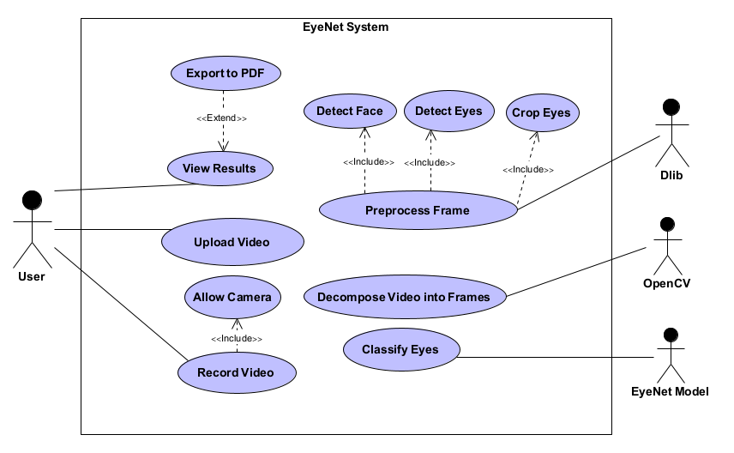

Figure 25 System's use case

## System Activity Diagram

A system activity diagram describes the internal process that occurs in our system, which actor handles each action, and what the step-by-step sequence of actions is.

Figure 26 System’s activity diagram

## System User Interface

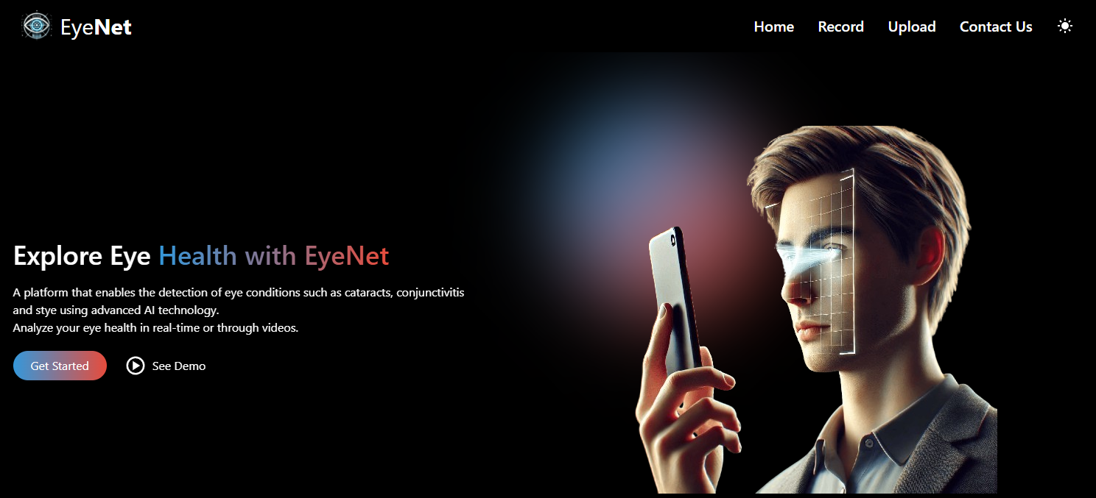

Figure 27 System's landing page

Figure 28 System's get started page

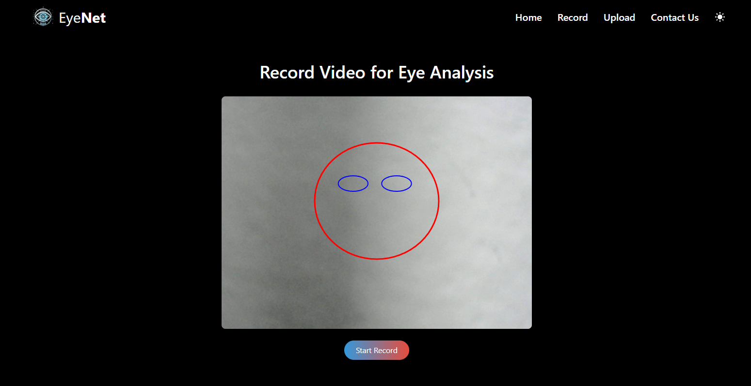

Figure 29 System’s upload/record video screen

Figure 30 System's analyzing screen

Figure 31 System’s results screen, user can see the cropped eyes from the video he uploaded/recorded, the probability for each classification and a short summary and suggestions for future treatments.

# Verification and Evaluation

## Evaluation

The primary goal of this project is to create a system capable of accurately detecting external eye conditions, such as cataracts, styes, and conjunctivitis, using videos or images captured by mobile or computer cameras. The system's success will be evaluated based on several key criteria. First, achieving high classification accuracy across various conditions and video formats will be measured using metrics like precision, recall, and F1 scores. Additionally, the system must process video files efficiently, delivering results promptly without performance degradation for larger files. A user-friendly interface is also essential, allowing users to easily upload videos, view results, and export findings, with feedback gathered to assess satisfaction and ease of use.

To ensure robustness, the system must perform effectively under varying conditions, such as poor lighting, occlusions, and different resolutions. It must also handle edge cases reliably, providing clear and actionable error messages for issues like corrupted files, unsupported formats, or videos without detectable eyes.

The evaluation process will include extensive testing using real-world datasets and simulated challenging scenarios to assess the system’s accuracy and resilience. All findings will be documented and analyzed to ensure the project meets its intended objectives and delivers a reliable and practical solution.

## Verification

Due to the iterative nature of our development process, we have divided the project into several modules: EyeNet Model, Video Processing, Camera Integration, Web-Application, and Data Analysis. Each module will be tested independently to ensure optimal functionality, followed by integration testing to verify the overall system. Testing methods will include unit testing, manual QA, and system-level testing for performance and usability.

|  |  |  |  |
| --- | --- | --- | --- |
| **No.** | **Module** | **Tested Function** | **Expected Result** |
| 1 | EyeNet Model | Classification Accuracy | Achieve classification accuracy >90% across all eye conditions. |
| 2 | EyeNet Model | False Positive and Negative Rates | Maintain a False Positive Rate (FPR) and False Negative Rate (FNR) <10%. |
| 3 | EyeNet Model | Model Response Time | Provide classification results within 500ms per frame. |
| 4 | Video Processing | Frame Decomposition | Decompose videos into individual frames accurately and efficiently. |
| 5 | Video Processing | Eye Region Cropping | Detect and crop left and right eye regions accurately for all valid frames. |
| 6 | Video Processing | Frame Preprocessing | Apply preprocessing (resizing, filtering) without altering critical features. |
| 7 | Camera Integration | Video Recording | Record high-quality videos from the device camera and save them locally. |
| 8 | Camera Integration | Camera Permissions | Handle denied camera permissions gracefully with appropriate error messages. |
| 9 | Web-Application | Video Upload and Processing | Allow users to upload or record videos and process them without errors. |
| 10 | Web-Application | User Interface Usability | Ensure the UI is intuitive and easy to navigate, validated by user feedback. |
| 11 | Web-Application | Results Display | Display classification results for each eye with clear visualizations. |
| 12 | Web-Application | Export Results as PDF | Generate accurate, well-formatted PDF reports of analysis results. |
| 13 | Web-Application | Page Loading and Navigation | Load the landing page in under 2 seconds and provide seamless navigation. |
| 14 | Data Analysis | Aggregated Classification Results | Calculate and display the average classification result for all processed frames. |
| 15 | Data Analysis | Data Accuracy | Ensure all stored and analyzed data matches the expected results. |
| 16 | System Integration | Processing Time for Short Videos (<30 sec) | Process short videos within 15 seconds. |
| 17 | System Integration | Handling Large Video Files (500MB) | Process large videos efficiently without performance degradation. |
| 18 | System Integration | Error Handling for Unsupported Formats | Display appropriate error messages for unsupported file formats. |
| 19 | System Integration | Error Handling for Corrupted Files | Notify users when a corrupted file is uploaded. |
| 20 | System Integration | Robustness in Poor Lighting Conditions | Maintain classification accuracy under varied lighting conditions. |

Table 8 Our modules, the test functions and the expected results

# References

[1] Bourne, R. R. A., et al. "Magnitude, temporal trends, and projections of the global prevalence of blindness and distance and near vision impairment: a systematic review and meta-analysis." The Lancet Global Health, vol. 5, no. 9, 2017, pp. e888-e897.

[2] Flaxman, S. R., et al. "Global causes of blindness and distance vision impairment 1990-2020: a systematic review and meta-analysis." The Lancet Global Health, vol. 5, no. 12, 2017, pp. e1221-e1234.

[3] World Health Organization. "Blindness and vision impairment." [Online]. Available: <https://www.who.int/news-room/fact-sheets/detail/blindness-and-visual-impairment>. [Accessed: Dec. 27, 2024].

[4] Ackland, P., et al. "The Lancet Global Health Commission on Global Eye Health: vision beyond 2020." The Lancet Global Health, vol. 9, no. 4, 2021, pp. e489-e551.

[5] Litjens, G., et al. "A survey on deep learning in medical image analysis." Medical Image Analysis, vol. 42, 2017, pp. 60-88.

[6] Wang, X., et al. "Residual attention network for image classification." Proceedings of the IEEE Conference on Computer Vision and Pattern Recognition (CVPR), 2017, pp. 3156-3164.

[7] Centers for Disease Control and Prevention (CDC). "Conjunctivitis (Pink Eye)." [Online]. Available: <https://www.cdc.gov/conjunctivitis/index.html>. [Accessed: Dec. 27, 2024].

[8] Health.com. "Cataracts: Overview." [Online]. Available: <https://www.health.com/cataracts-overview-7376241>. [Accessed: Dec. 27, 2024].

[9] Mayo Clinic. "Sty: Symptoms and Causes." [Online]. Available: <https://www.mayoclinic.org/diseases-conditions/sty/symptoms-causes/syc-20378017#causes>. [Accessed: Dec. 27, 2024].

[10] Mayo Clinic. "Pink Eye (Conjunctivitis): Symptoms and Causes." [Online]. Available: <https://www.mayoclinic.org/diseases-conditions/pink-eye/symptoms-causes/syc-20376355>. [Accessed: Dec. 27, 2024].

[11] Healthline. "Slit Lamp Exam: Purpose, Procedure and Results." [Online]. Available: <https://www.healthline.com/health/slit-lamp-exam>. [Accessed: Dec. 27, 2024].

[12] Bovik, A. The Essential Guide to Video Processing. 2nd ed., Academic Press, 2013.

[13] Feichtenhofer, C., et al. "Temporal modeling in convolutional neural networks for video understanding." International Journal of Computer Vision, vol. 128, no. 1, 2020, pp. 67-87.

[14] Birchfield, T. A. "Noise Reduction Techniques for Video Processing." Proceedings of IEEE International Conference on Multimedia and Expo (ICME), 2005, pp. 654–657.

[15] Zhao, Z., et al. "Object Detection with Deep Learning: A Review." IEEE Transactions on Neural Networks and Learning Systems, vol. 30, no. 11, 2019, pp. 3212–3232.

[16] Viola, P., and Jones, M. J. "Robust real-time object detection." International Journal of Computer Vision, 2004.

[17] Viola, P., and Jones, M. J. "An evaluation study of face detection by Viola-Jones algorithm." International Journal of Advanced Computer Science and Applications, vol. 11, no. 5, 2020, pp. 38–46.

[18] Bradski, G. "The OpenCV Library." *Dr. Dobb's Journal of Software Tools*, 2000.

[19] Zhang, Z., et al. "MTCNN++: A CNN-based face detection algorithm inspired by MTCNN." *The Visual Computer*, vol. 39, no. 3, 2023, pp. 1–10.

[20] Singh, A., et al. "Evaluating Dlib, Haar Cascade, and MTCNN face detectors." *Proceedings of the International Conference on Machine Vision and Image Processing (MVIP)*, 2022, pp. 112–118.

[21] Redmon, J., et al. "A comparative study of MTCNN, Viola-Jones, SSD, and YOLO face detection algorithms." *IEEE Access*, vol. 10, 2022, pp. 50675–50689.

[22] Richards, B. D., et al. "Detection of leukocoria using a smartphone-based application: CRADLE white reflex app." *Journal of the American Association for Pediatric Ophthalmology and Strabismus (AAPOS)*, vol. 23, no. 6, 2019, pp. 307.e1-307.e5. [Online]. Available: <https://pubmed.ncbi.nlm.nih.gov/31616792/>. [Accessed: Dec. 27, 2024].

[23] AEYE Health. "AEYE Health - Transforming eye screening with AI." [Online]. Available: <https://www.aeyehealth.com/>. [Accessed: Dec. 27, 2024].

[24] MD EyeCare. "MD EyeCare." [Online]. Available: <https://www.mdeyecare.org/>. [Accessed: Dec. 27, 2024].

[25] Varadarajan, R., et al. "Deep learning for detecting diabetic retinopathy from eye fundus images." *Proceedings of the IEEE International Conference on Computer Vision (ICCV)*, 2019, pp. 64-72.

[26] Lecun, Y., Bengio, Y., and Hinton, G. "Deep learning." *Nature*, vol. 521, no. 7553, 2015, pp. 436-444.

[27] Kaggle. "Kaggle: Your Machine Learning and Data Science Community." [Online]. Available: <https://www.kaggle.com/>. [Accessed: Dec. 27, 2024].

[28] Roboflow. "Roboflow: Accelerating Computer Vision Development." [Online]. Available: <https://www.roboflow.com/>. [Accessed: Dec. 27, 2024].

[29] Perez, L., and Wang, J. "The Effectiveness of Data Augmentation in Image Classification." *arXiv preprint*, arXiv:1712.04621, 2017.

[30]GeeksforGeeks. "VGG-16 CNN Model." [Online]. Available: <https://www.geeksforgeeks.org/vgg-16-cnn-model/>. [Accessed: Dec. 27, 2024].

[31] He, K., et al. "Deep Residual Learning for Image Recognition." *arXiv preprint*, arXiv:1512.03385, 2015. [Online]. Available: <https://arxiv.org/abs/1512.03385>. [Accessed: Dec. 27, 2024].

[32] Szegedy, C., et al. "Rethinking the Inception Architecture for Computer Vision." *arXiv preprint*, arXiv:1512.00567, 2015. [Online]. Available: <https://arxiv.org/abs/1512.00567>. [Accessed: Dec. 27, 2024].

[33] Huang, G., et al. "Densely Connected Convolutional Networks." *Proceedings of the IEEE Conference on Computer Vision and Pattern Recognition (CVPR)*, 2017, pp. 4700–4708. [Online]. Available: <https://arxiv.org/abs/1608.06993>. [Accessed: Dec. 27, 2024].

[34] Rahim, M. S. M., et al. "Is Attention all You Need in Medical Image Analysis? A Review." *IEEE Access*, vol. 10, 2022, pp. 70650–70665. [Online]. Available: <https://ieeexplore.ieee.org/document/10376277>. [Accessed: Dec. 27, 2024].

[35] Zhang, Y., et al. "Residual Dense Network Based on Channel-Spatial Attention for the Scene Classification of a High-Resolution Remote Sensing Image." *Remote Sensing*, vol. 12, no. 11, 2020, p. 1887. [Online]. Available: <https://www.mdpi.com/2072-4292/12/11/1887>. [Accessed: Dec. 27, 2024].

[36] Li, H., et al. "Channel-Attention-Based DenseNet Network for Remote Sensing Image Scene Classification." *IEEE Geoscience and Remote Sensing Letters*, vol. 17, no. 8, 2020, pp. 1351–1355. [Online]. Available: <https://ieeexplore.ieee.org/document/9141394>. [Accessed: Dec. 27, 2024].

[37] Python Software Foundation. "Python Programming Language – Official Website." [Online]. Available: <https://www.python.org/>. [Accessed: Dec. 27, 2024].

[38] Ramírez, S. "FastAPI – Modern, Fast (High-Performance) Web Framework for Python 3.7+." *FastAPI Documentation*, 2024. [Online]. Available: <https://fastapi.tiangolo.com/>. [Accessed: Dec. 27, 2024].

[39] Meta Platforms, Inc. "React – A JavaScript Library for Building User Interfaces." *React.dev*, 2024. [Online]. Available: <https://react.dev/>. [Accessed: Dec. 27, 2024].